# CS 340 README

## About the Project/Project Title

As a software engineer for Global Rain, I am provided the opportunity to complete code for the international rescue-animal training company Grazioso Salvare. They have hired my expertise as lead developer in order to create a software application that will use existing data from animal shelters in order to complete identification and categorization of available animals. This is a full-stack development process with the goal of a fully functional client-facing web application dashboard and a linked database. This dashboard is now fully functional and provides options for filtering animals as well as their location and preferred status on a pie chart.

## Motivation

Grazioso Salvare is motivated to receive such an application due to their function in provided good candidates for search-and-rescue training. By ensuring the correct candidates, these animals can be trained to help rescue humans and animals that are in danger. Grazioso Salvare must honor its agreement with the nonprofit agency that provides it with data from five animal shelters under its control within Austin, Texas. Grazioso Salvare believes that an application that meets the purpose of this project will aid them greatly in the process of using the data from these shelters to select candidates.

## Getting Started

First, a local copy of the database must be initialized and python functionality added. This is begun by importing the necessary data files in the form of a csv. The mongo import command is used to complete this import within the Linux terminal. Mongo database most be installed for this to function correctly.

Next, users and access privileges are determined by implementing the necessary commands within the terminal and mongo shell. The port being used can easily be obtained with the printenv command.

Other imports completed within the py file must be the mongo client and bson object id resources.

Access to the database can be tested by using the correct user parameters and associated database commands. This was first done in the terminal; however, Jupyter Notebook is recommended to create and test the code for what will be the py module.

Jupyter Notebook and RStudio are used to create the py file which is used to complete CRUD functionality.

You will also use PyMongo as a dependency in this program, so that must be installed. A link to instructions is provided in the installation section of this readme.

## Installation

Installation of Jupyter Notebook can be completed here:

<https://jupyter.org/>

These are the installation instructions: <https://jupyter.org/install>

Rstudio installation can be completed using these instructions:

<https://rstudio-education.github.io/hopr/starting.html>

I used Rstudio to create the py file used for CRUD functionality.

If the Linux operating system needs to be installed, a copy of your preferred Linux distro can be found here:

<https://www.linux.org/pages/download/>

This project was completed using the Virtual Desktop Apporto, found here:

<https://www.apporto.com/>

I preferred to use Firefox, but other browsers could be used:

<https://www.mozilla.org/en-US/firefox/linux/>

MongoDB must be installed into Linux for the mongo shell and CRUD functionality to work.

<https://www.mongodb.com/docs/manual/installation/>

The PyMongo installation instructions can be found here:

<https://pypi.org/project/pymongo/>

This project utilizes Dash Core Components, DataTable, and Leaflet, which are importedin order to ensure proper dashboard function.

Resources for these components are shown here:

<https://dash.plotly.com/dash-core-components>

<https://dash.plotly.com/datatable>

<https://dash-leaflet-docs.onrender.com/>

**Python Module Purpose**

This Python Module allows users to complete CRUD functionality within a MongoDB database. The module contains a CRUD class, named AnimalShelter, which enables four functions: Create, Read, Update, and Delete. The Create method will enable inserts of entries into a document within a MongoDB database and collection. The Read method enables queries for documents from the MongoDB database and collection that the user specifies. Update allows users to change information within a document and collection. Using the Delete method will enable removal of entries within specified documents. These CRUD methods represent the intended purpose of the module and examples are shown of its use later in this readme.

**Dash Framework Purpose**

The purpose of the Dash framework is that it allows creation of the view and controller structure for the web application. I am able to use this to determine the visual style, components, and function of the dashboard. Dash Core Components are used to build the interface and its interactable parts. Dash DataTable provides the necessary code for the data table on the dashboard. This also contains the necessary filters. Dash Leaflet is responsible for the geo-location component of the dashboard.

## Usage

Functional code of the Python Module is provided here with the appropriate tests. Usage examples of Create, Read, Update, and Delete are shown as well as the necessary setup steps before CRUD functionality can be used.

### Code Example

Start by importing the csv for the Austin Animal Center Outcomes data set via a mongoimport command with the additional –type and –headliner specifications:

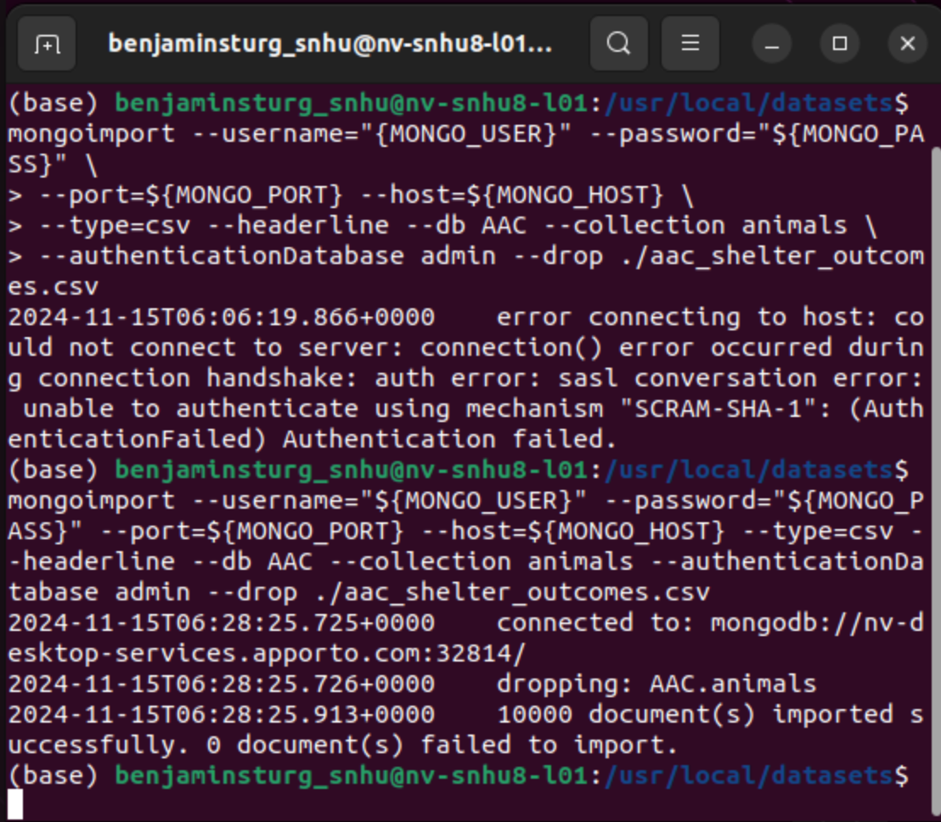

Following this a user must be created with the appropriate credentials. This is shown with additional access testing:

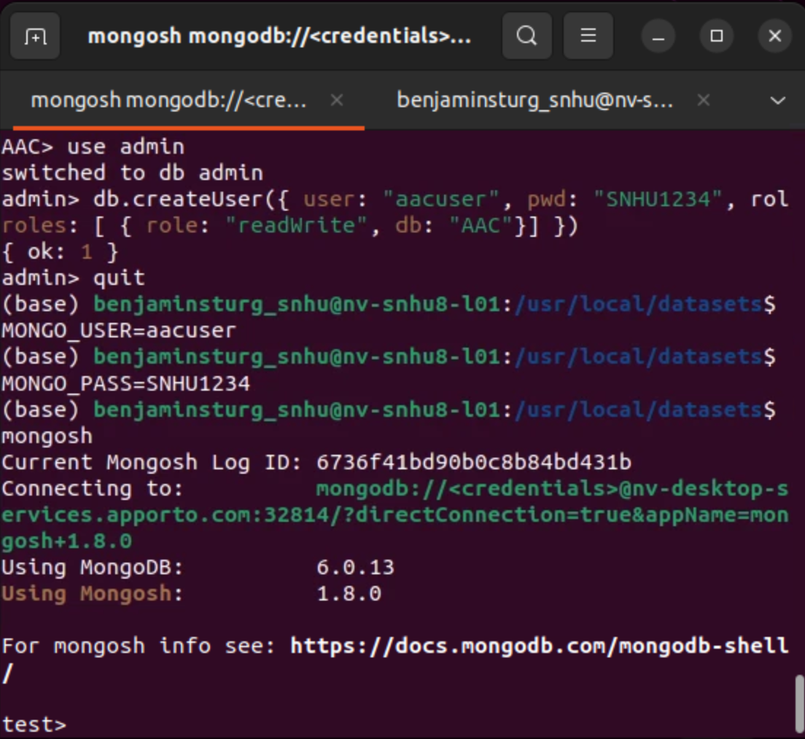

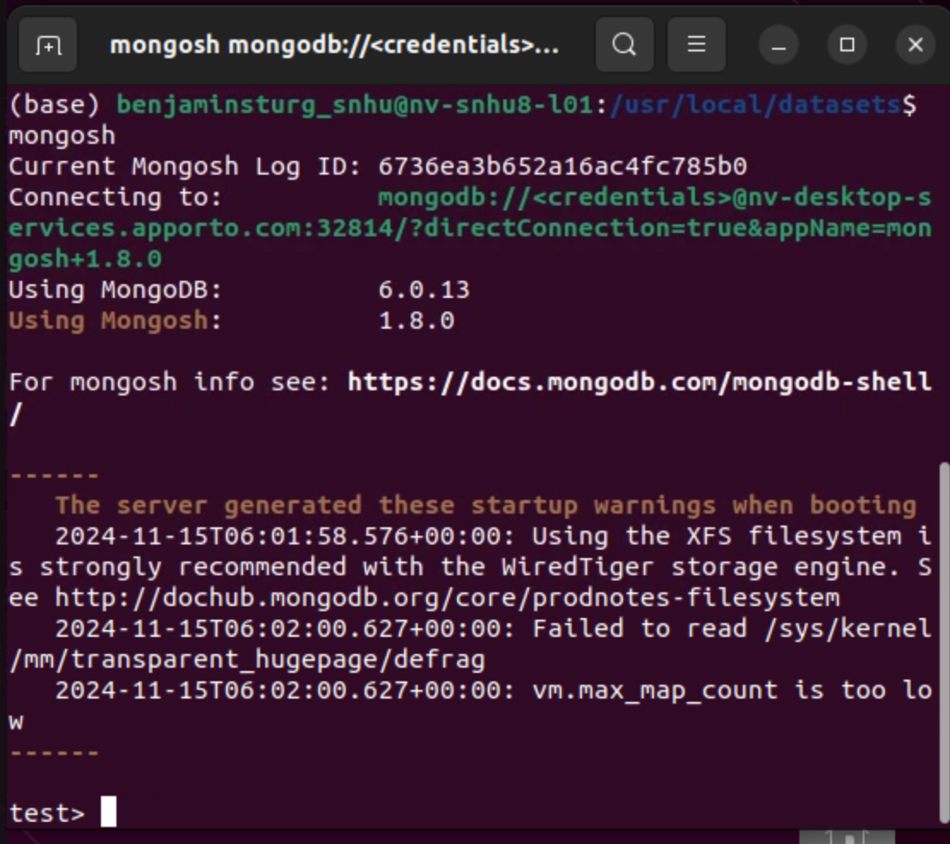

The following code was created using Jupyter Notebook and then implemented into a py file using RStudio:

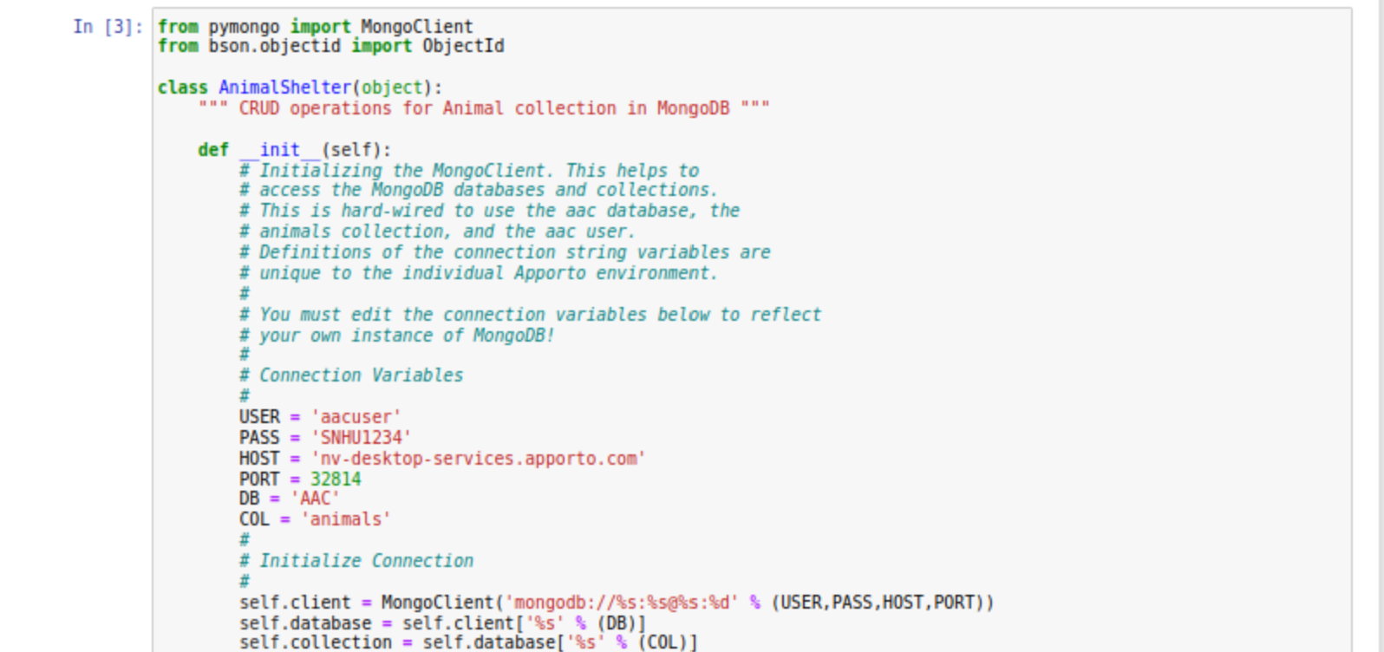

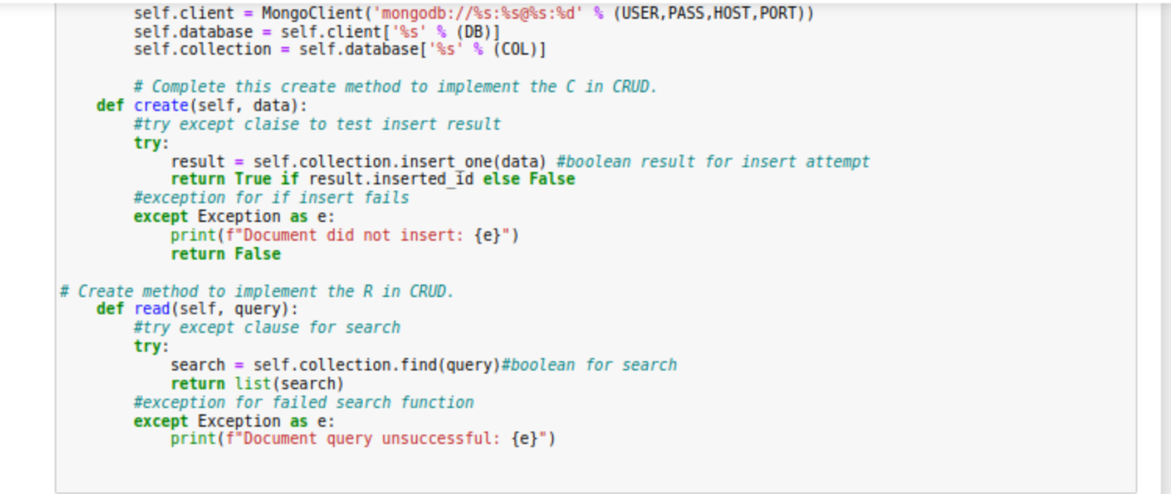

As can be seen, the necessary create and read methods have been implemented and are accessible to the database. Additional update and delete methods are shown below:

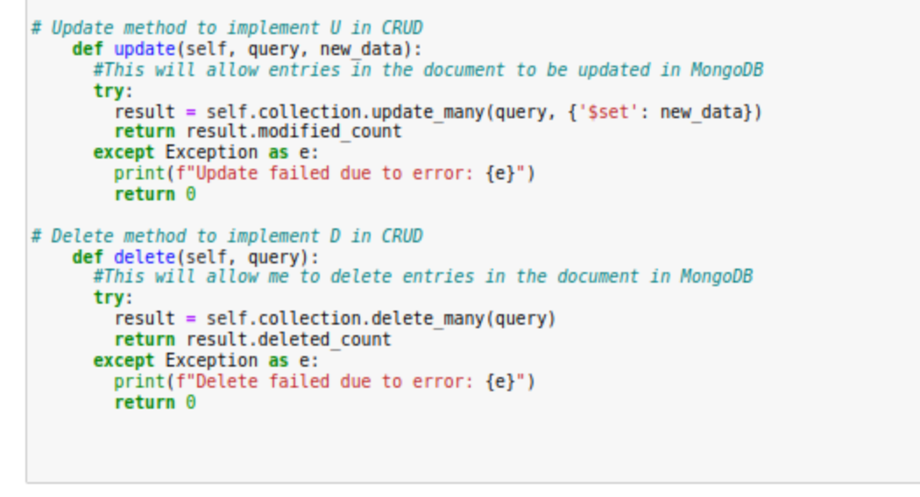

### Tests

I was able to test CRUD functionality by creating a test animal object and then attempting the create and read methods with that animal. This is shown here:

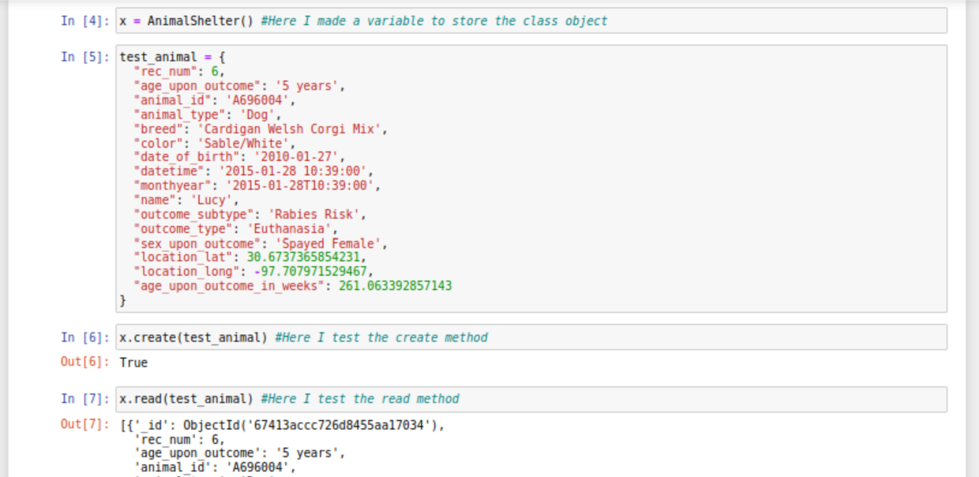

Additional tests were completed for the update and delete methods. Read commands are given for the CRUD object in order to show that an attempt to read the animal produces no output because the animal has been updated or deleted:

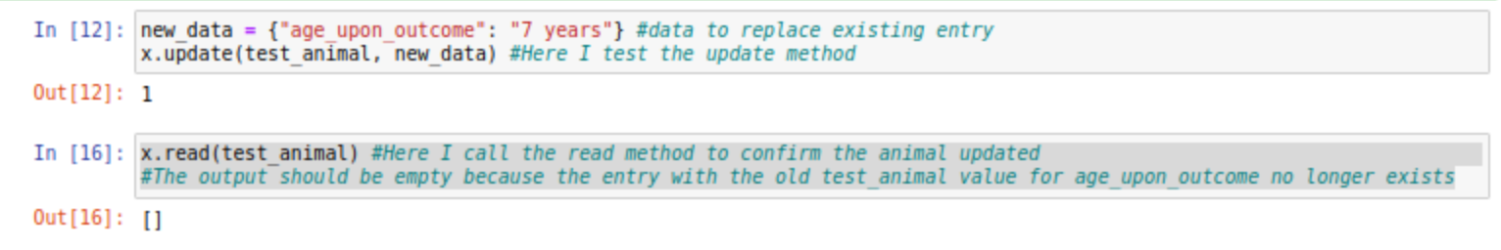

Following this is the delete test:

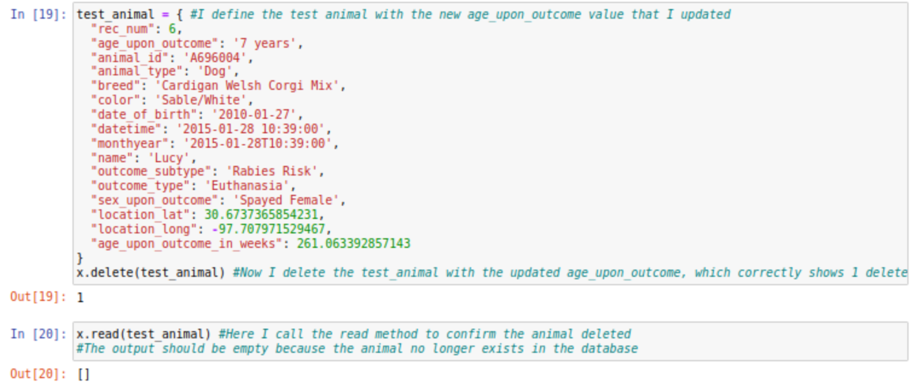

Next is shown the code for the dashboard:

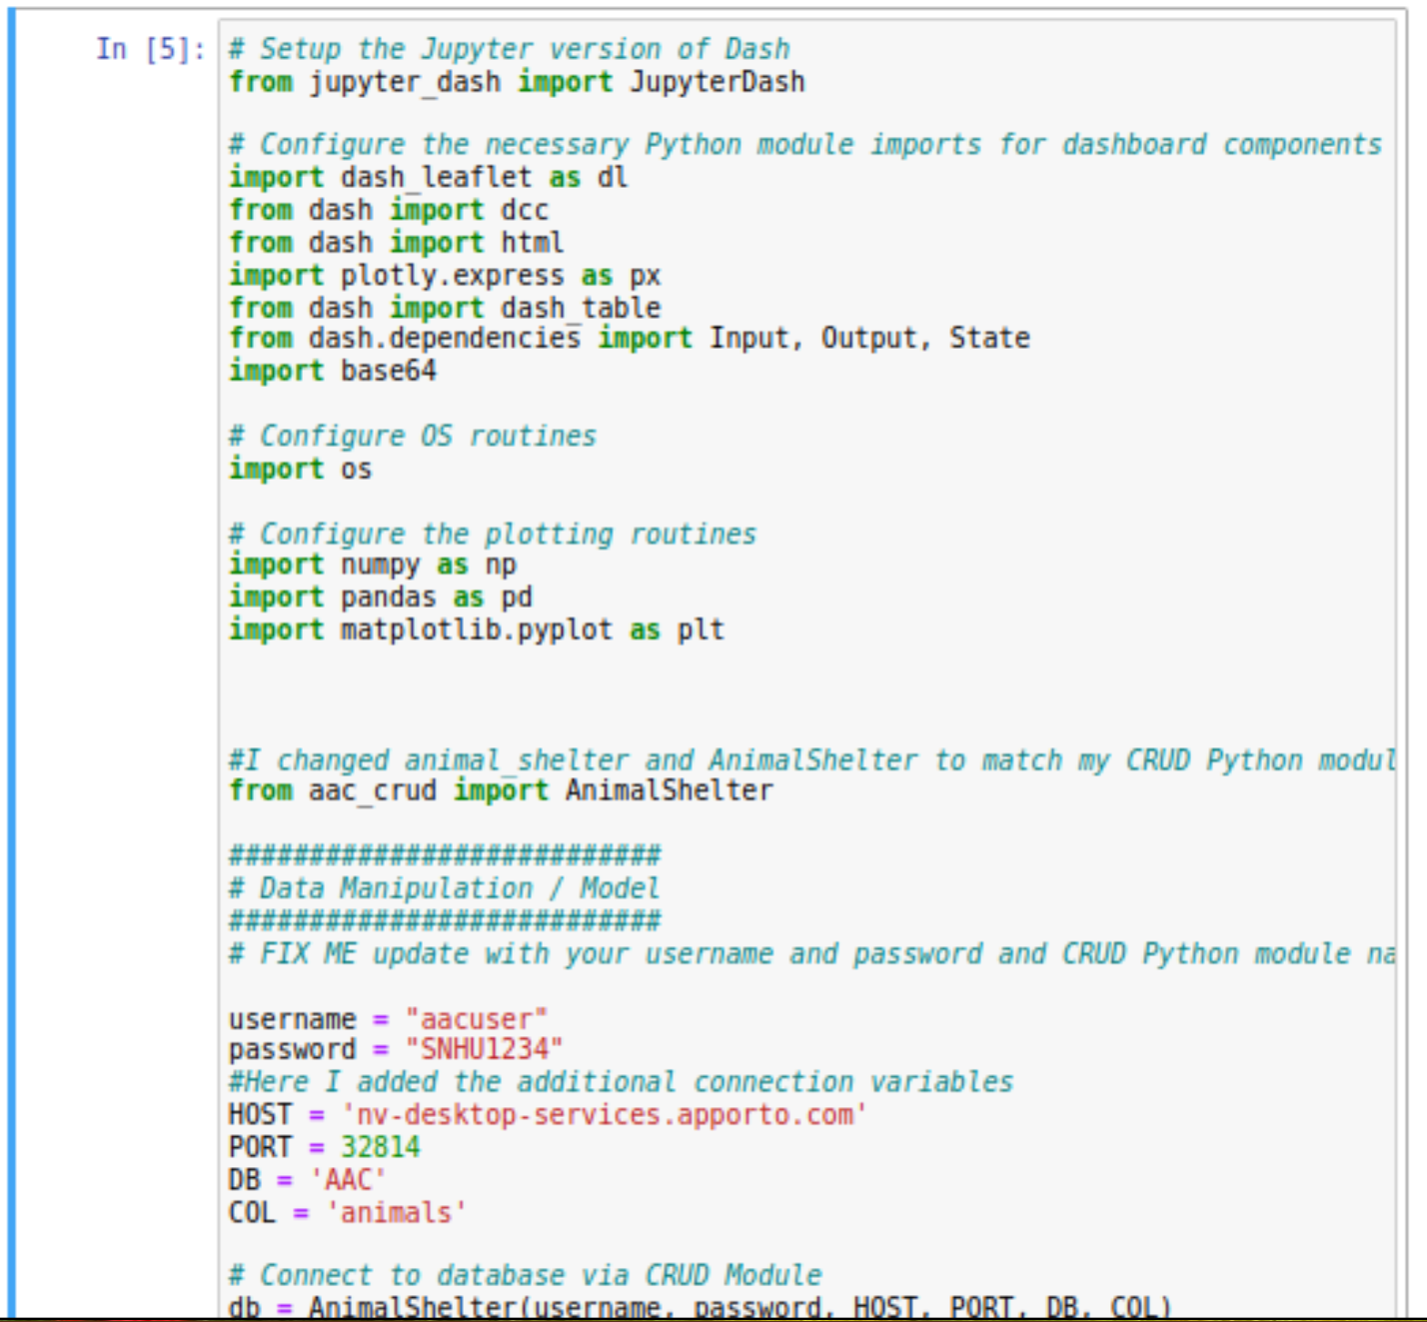

Example code for dashboard imports and stetup.

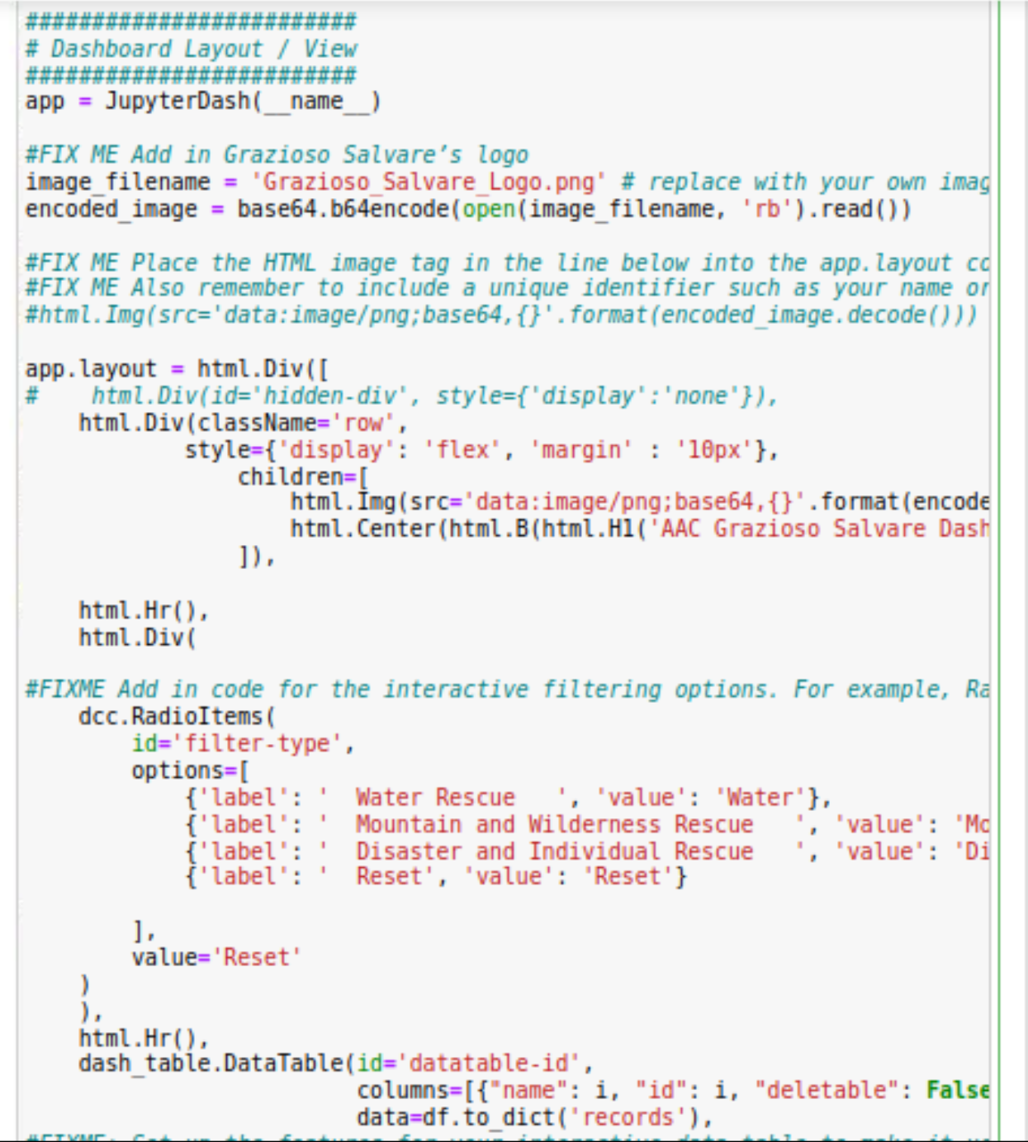

Example Code for dashboard layout image and filter radio buttons

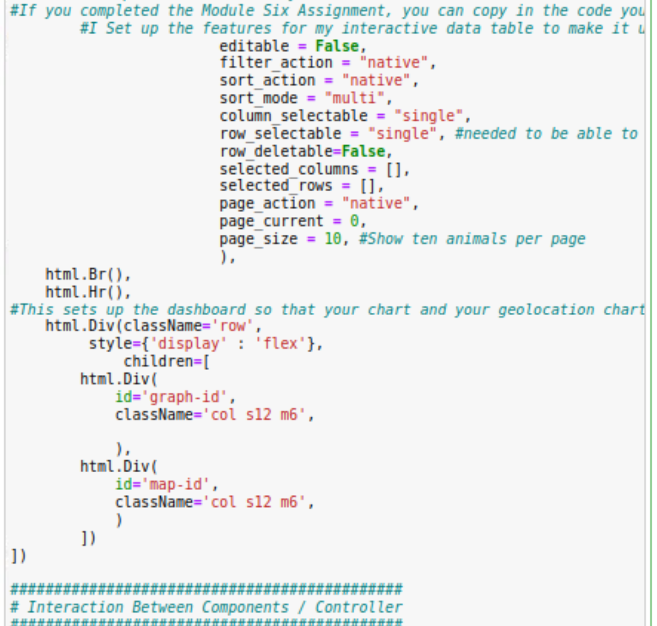

Example code for dashboard selection interactivity and geolocation chart.

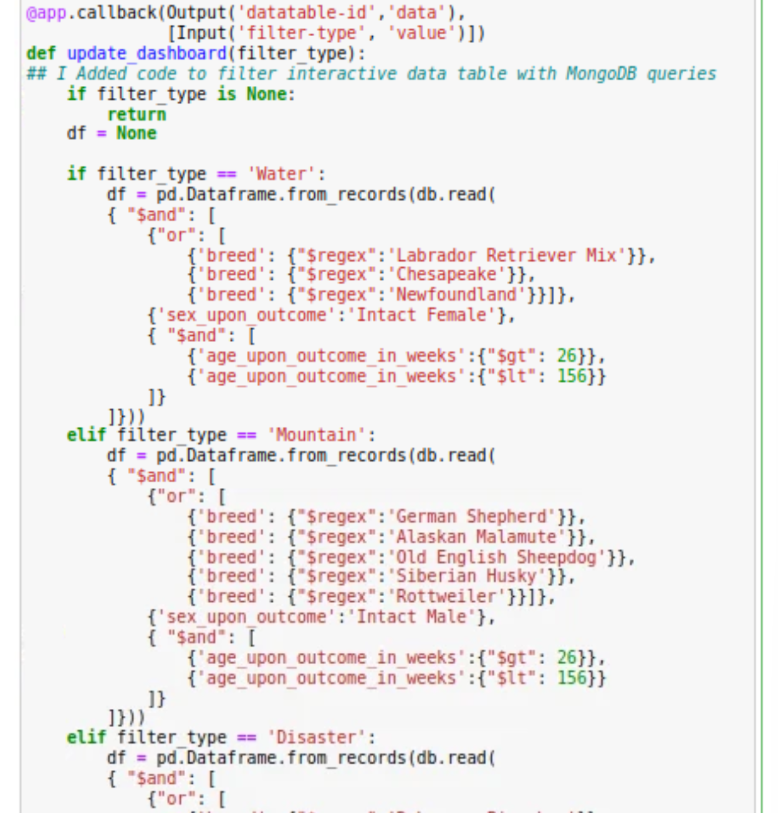

Example code for Filters

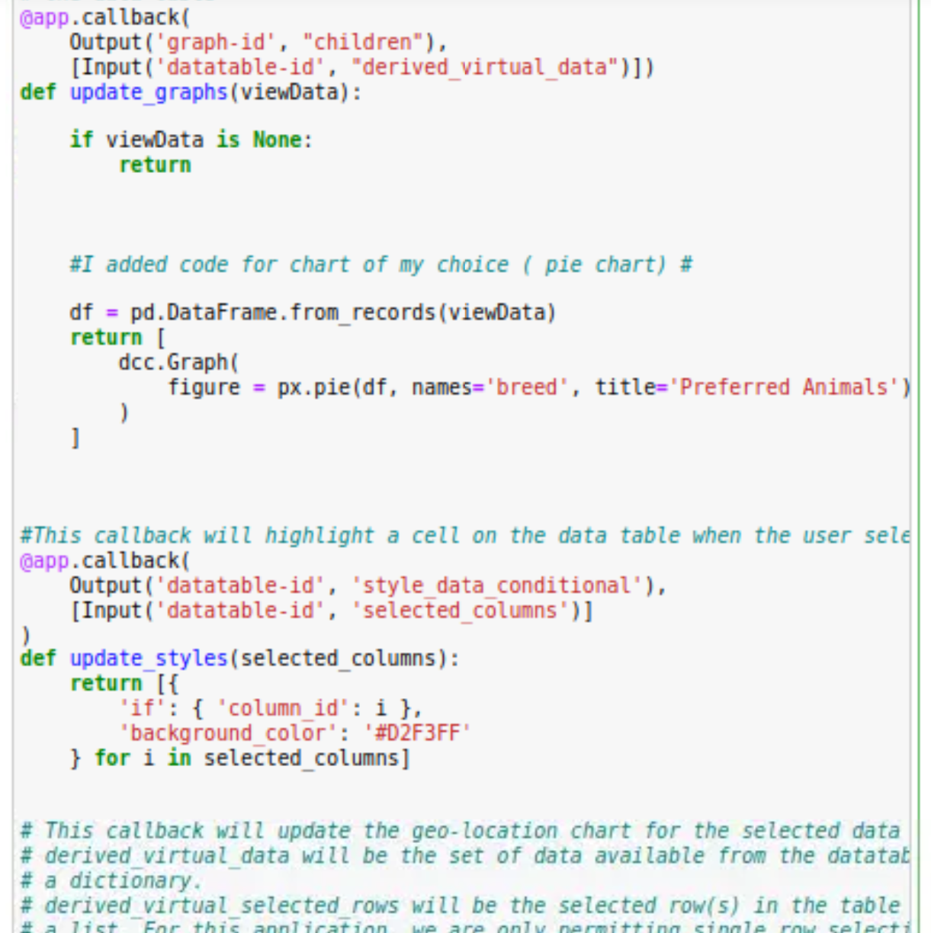

Callbacks for pie chart and cell highlights.

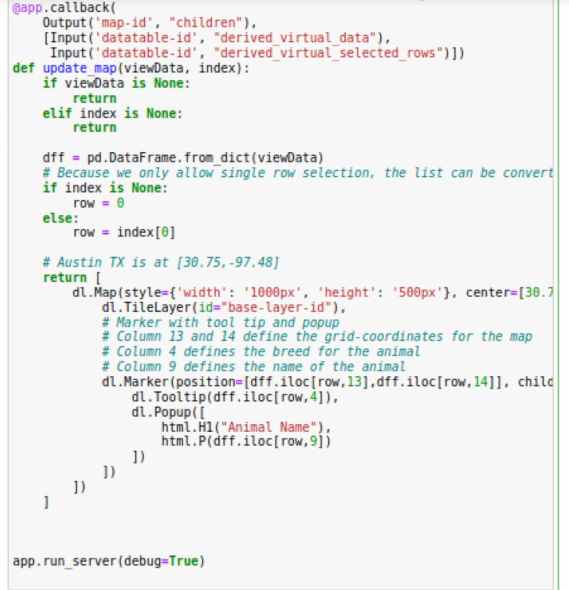

This shows the call back for updating the geolocation chart.

### Screenshots

I have chosen to provide some additional screenshots showcasing work done on the project:

Additional testing:

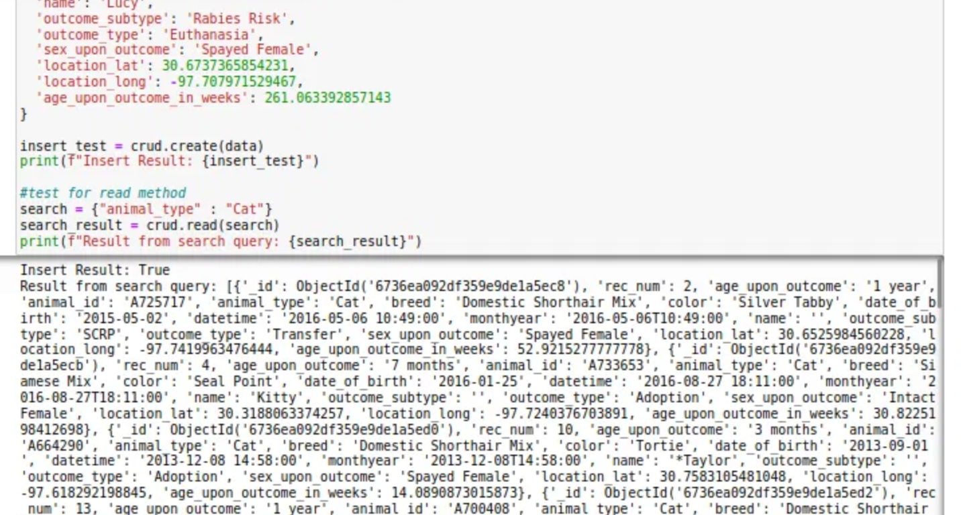

Mongo import command:



**Functional Dashboard Screenshots**

Here is shown the functional dashboard and its components:

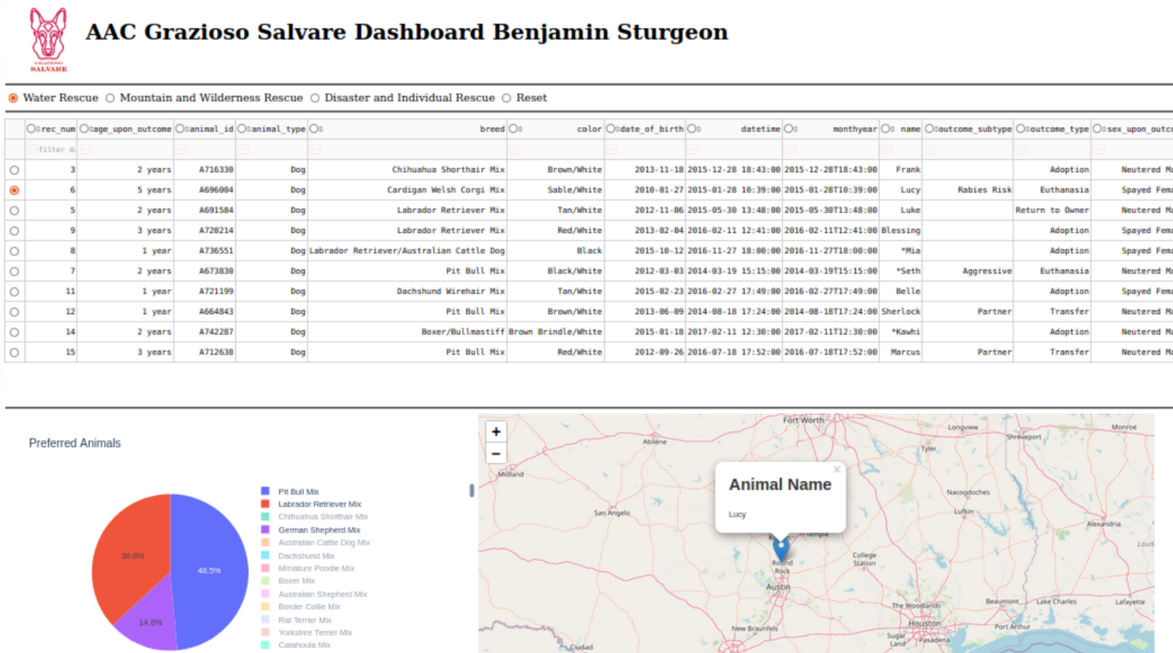

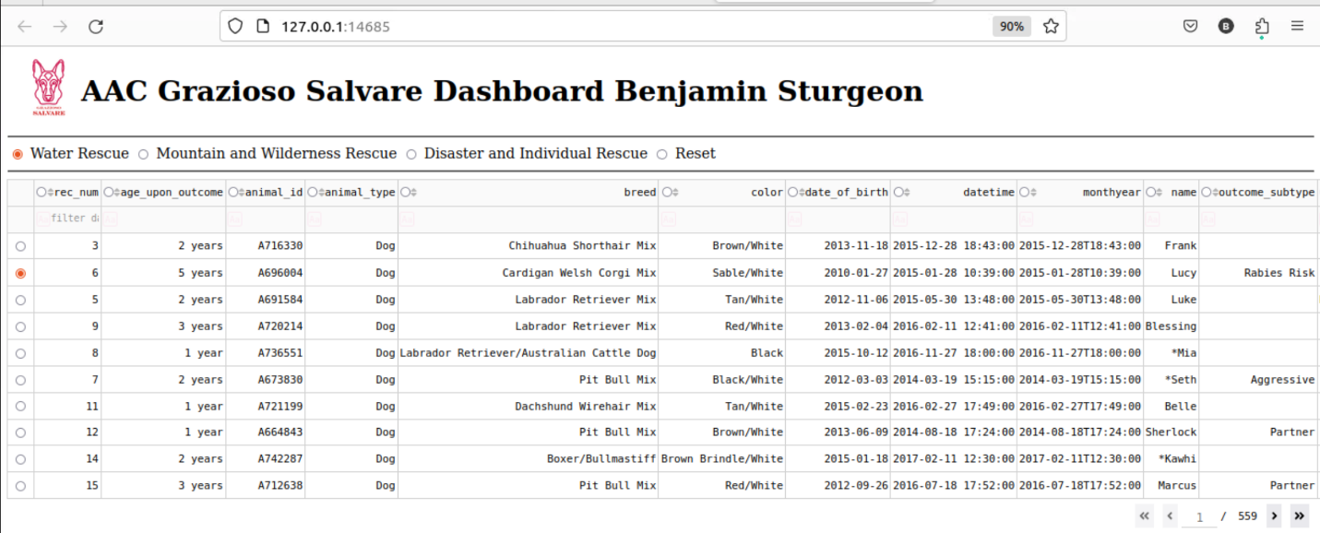

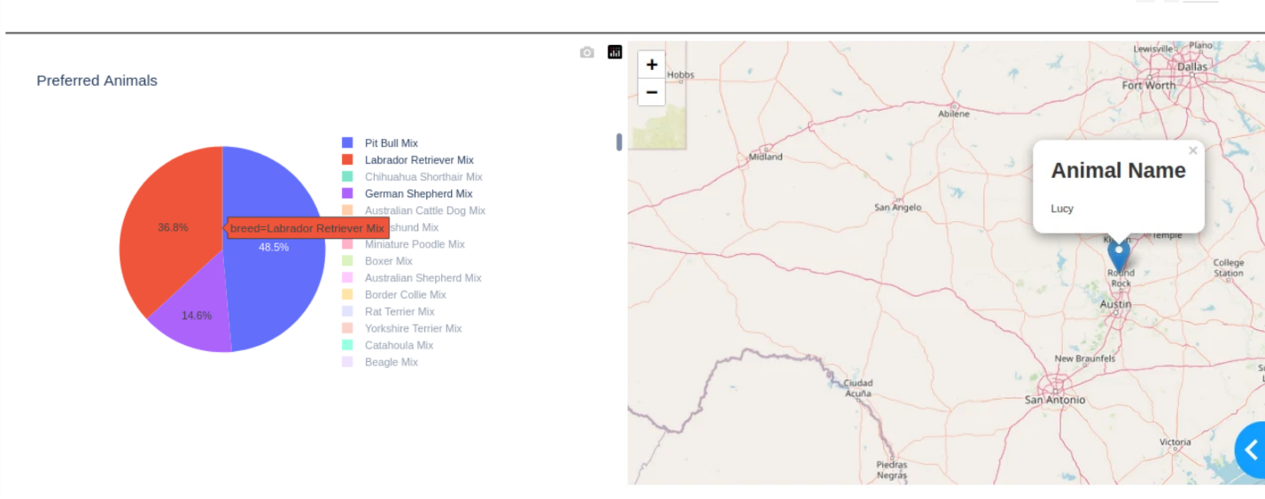

## Roadmap/Features (Optional)

Project is now in Maintenance phase.

**Challenges**

The first challenge that I experienced was working in the terminal. The terminal is frustrating because it does not allow for any mistakes, and all code must be resubmitted if any mistakes occur. This lack of forgiveness for human error was overcome with methodical review of all associated commands and queries.

I had an additional challenge when working on code for the dashboard because the associated queries were relatively complex. This meant that syntax errors were a high risk when creating the associated queries for filters. I was able to overcome this by utilizing the same code structure for each of my queries so that I only had to change small parts in order to alter the query to its desired output.

## Contact

Benjamin Sturgeon